Gastroenterology Referral Form  Patient details:  First name: <<firstname>>  Surname: <<surname>>  Address: <<street1>><<street2>><<ssuburb>>  State: <<state>>  Postcode: : <<postcode>>  Phone: <<phoneh>>  DOB: <<dob>> |  |   MBBS BMedSci FRACP  Provider No. 264383

Request:
Consultation
Colonoscopy
Gastroscopy

Current medications and alerts:
<<printclinicalhistory>>
Diabetes - on tablets or insulin (please circle)
Anticoagulants - warfarin, Plavix, Xarelto, Eliquis, other
Renal impairment

Clinical details:

Referring Doctor’s details:
Doctor’s name: <<docname>>
Address: <<practiceaddr1>> <<practiceaddr2>> <<practiceaddr3>>
Phone: <<practicephone>>
Provider number: <<docprov>>
Signature:
Date: <<dates>>
Phone: 07 3193 0877 Fax: 07 3319 6466 Email: reception@drjasonhuang.com.au
www.drjasonhuang.com.au
Locations:  St Andrew’s War Memorial Hospital Sessional Suites, Level 4  457 Wickham Terrace  Brisbane QLD 4001 | Holy Spirit Northside Private Hospital Arnold Janssen Building, Suite 15, Level 1 627 Rode Road  Chermside QLD 4032
Correspondence: PO Box 206, Ashgrove QLD 4060
For all appointments please call: 07 3193 0877

Locations:
St Andrew’s War Memorial Hospital Sessional Suites, Level 4, Yellow lifts, 457 Wickham Terrace  Brisbane QLD 4001 | Holy Spirit Northside Private Hospital Arnold Janssen Building, Suite 15, Level 1 627 Rode Road  Chermside QLD 4032
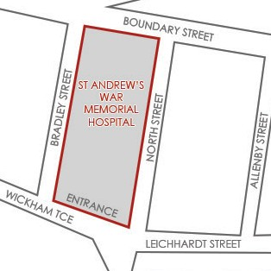 | 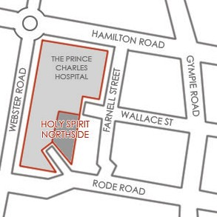
Notes:

